
The meeting of Satterthwaite Parish Council to be held in the Parish Room, Satterthwaite on Monday 2nd March 2026 at 7.30 pm for the purpose of transacting the business outlined in the agenda below.
Agenda
Item |  | Additional  information
Opening Administration
1 | Welcome and Introductions  Apologies  None received
2 | Declarations of interest  - To receive declarations by elected and co-opted members of disclosable pecuniary interests in respect of items on this agenda
3 | Requests for Dispensations  - The clerk to report any requests received since the previous meeting for dispensations to speak and/or vote on any matter where a member has a disclosable pecuniary interest.
4 | Minutes  - To authorise the Chair to review and sign last meetings minutes on 19th January 2026 | Minutes attached from 19th January 2026
Matters for consideration
5 | Public participation  - To receive comments and representations from members of the public in relation to any item on the agenda
6 | Updates on ongoing issues and actions from last meeting  Review of action log  - LDNPA and Dale Park caravan update – new shed reported  - Playground quotes  - Zurich insurance  - Observatory visit plans for community  - Village Parking  - Moor lane and motorcyclists – LDNPA suggested solutions, currently being improved for Cumbria way project  - Standing Orders/Financial regs  - Meeting with HIAMS  - Community Governance response – further consultation planned for residents  - Internal auditor to be enlisted prior to AGAR  - Formal complaint to Fibrus  - Complaint to W&F re community governance draft report – action to be closed  - AGAR to be completed | Action log
7 | Items for meeting not covered above  - White tailed Eagle project – further consultation planned but they are already being introduced in North Lakes prior to this closing
8 | Additional or urgent points to raise regarding Parish or Councillor matters
9 | Items for the Lengthsman
Planning
10 | Planning Consultations sought from Parish Council  - 7/2025/5659 1-5 Force Forge Cottages – supported  - 7/2025/5555 Bank Cottage Force Forge, installation of sewage treatment plant - supported
Finance
11 | Accounts since last meeting  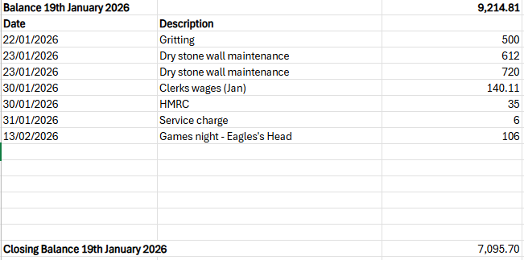
12 | Precept setting - action complete
Key correspondence, consultations and reports not covered above
13 | White tailed Eagle project – further consultation planned but they are already being introduced in North Lakes prior to this closing
Council calendar
14 | Observatory visit date to be arranged
Closing administration
15 | Agenda items for next meeting
16 | Next meeting date to be agreed  - 20th April 2026

